

DEVELOPER GUIDE

This Is a Developer Guide for The Website “**Address book**” Which is made by the Students of aptech for the purpose Of **E-Project.**

|  |  |  |
| --- | --- | --- |
| SN | ID | STUDENTS |
| 1 | Student1546927 | MUHAMMAD ARHAM . |
| 2 | Student1550980 | MUHAMMAD SAMEER |
| 3 | Student1549508 | AFFAN MAHMOOD |
| 4 | Student1530866 | SAMEER HUSSAIN |

FACULTY : MISS FARIHA SHAFIQ

BATCH CODE : 2402G1

CORDINATOR : MISS IQRA KHAN

SEMISTER : 2 (TERM)

SUBJECT : E PROJECT (ADDRESS BOOK)

FRONT END   
 (USER PANEL SITE)

* We have created two panels as required in the subject.
* USER PANEL
* ADMIN PANEL

‘The give image is refered to the USER PANEL interface. Here we have shown you the first interface of our user panel’

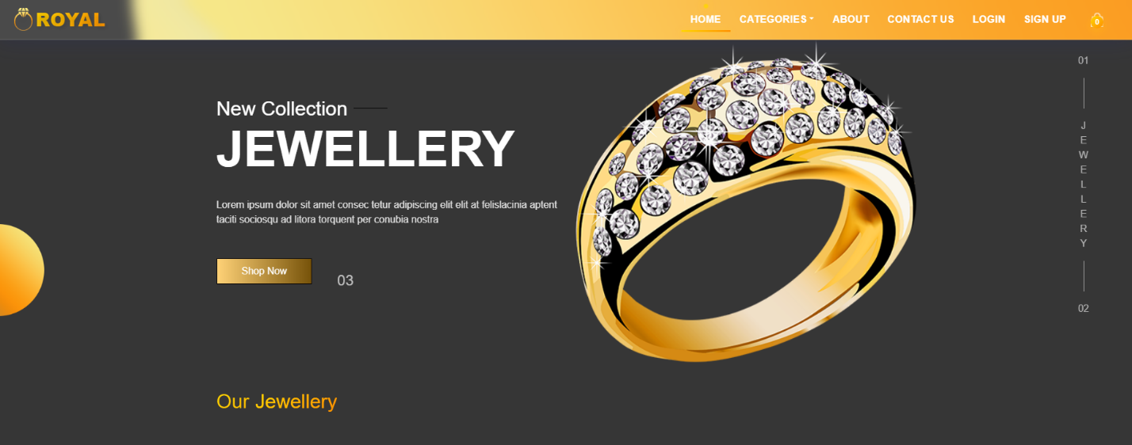THE FINAL LOOK

The code is give below

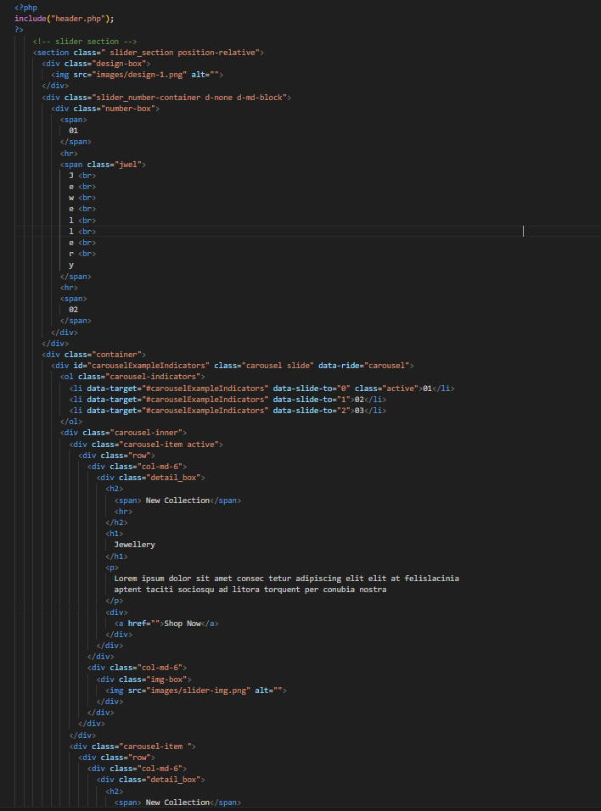

NAVBAR

* 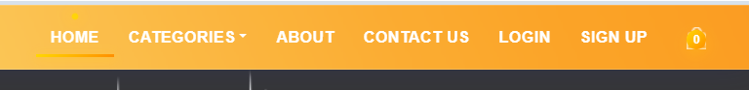There are six navbar items which show different categoris
* We have also add the add items logo which will show the number of purshased items.

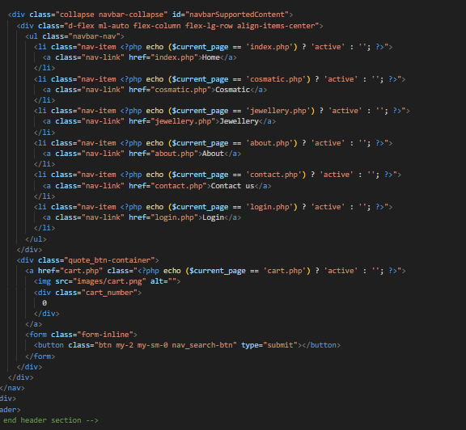

CARDS

* 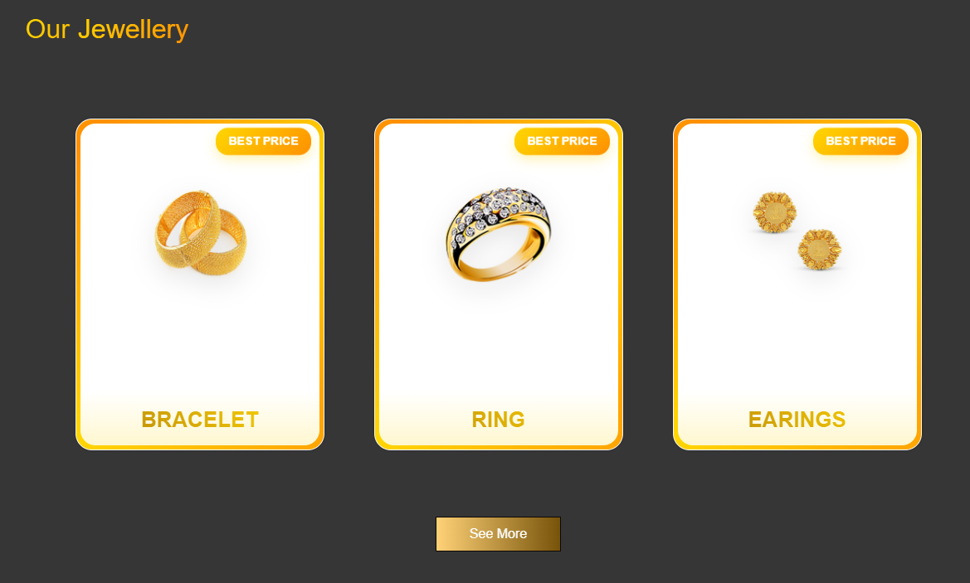We have displayed the 3 main cards which are representing the items.
* This portion is related towards jewellery .Which are representing three parts for example Bracelet , ring , ear rings.

SPECIAL WEDDING RING

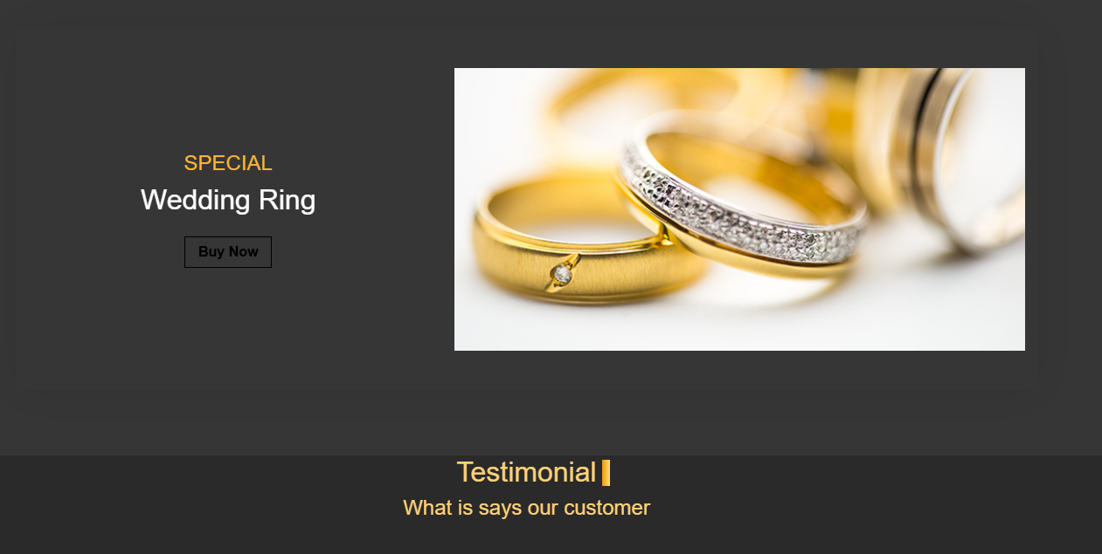

* This part is refered to the most special wedding ring of our jewellery.

THE CODE IS BELOW

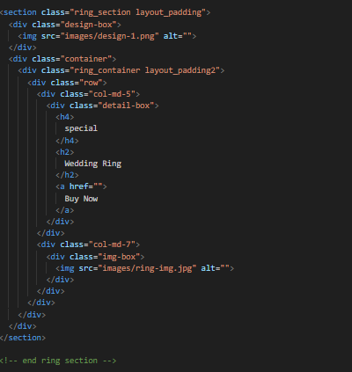

Testimonial

CUSTOMER SECTION

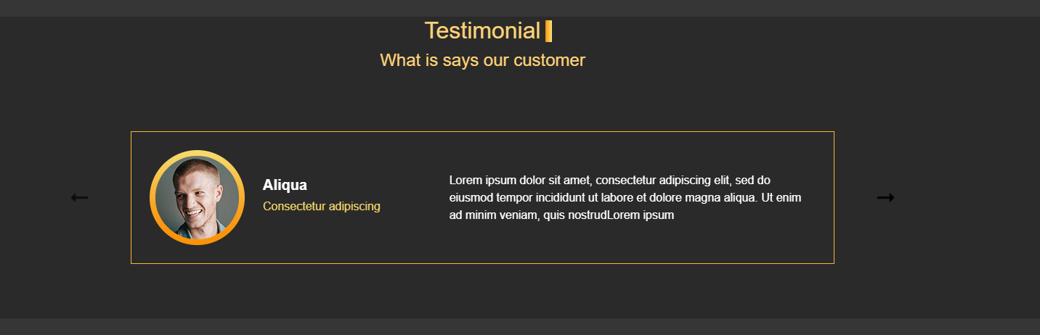THIS SECTION OF OUR HOME PAGE IS REFERED TO THE SEGISSION , FEEDBACK FOR THE ITEMS OF OUR WEBSITES.

* THE CODE OF THIS SECTION IS BELOW

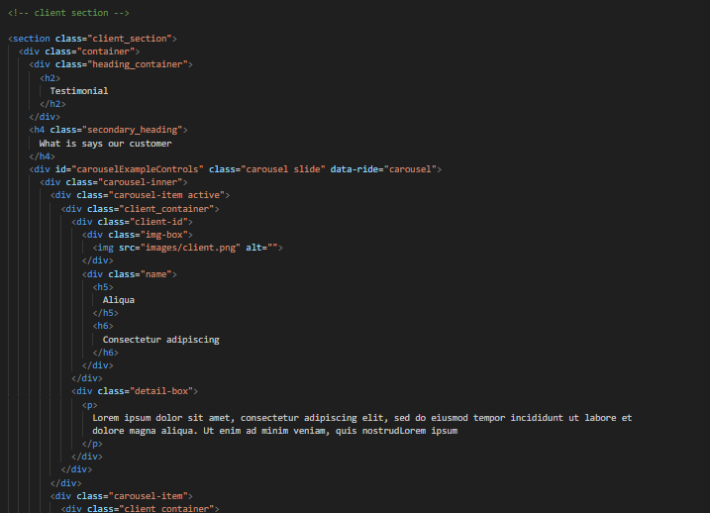

* WE HAVE DISPLAYED THE SUGESSION , FEESBACK AND SHORTOUT OF OUR CUSTOMERS THOSE WHO HAVE PURCHASE THE ITEMS FROM OUR WEBSITES

CONTACT FORM

(HOME PAGE)

* 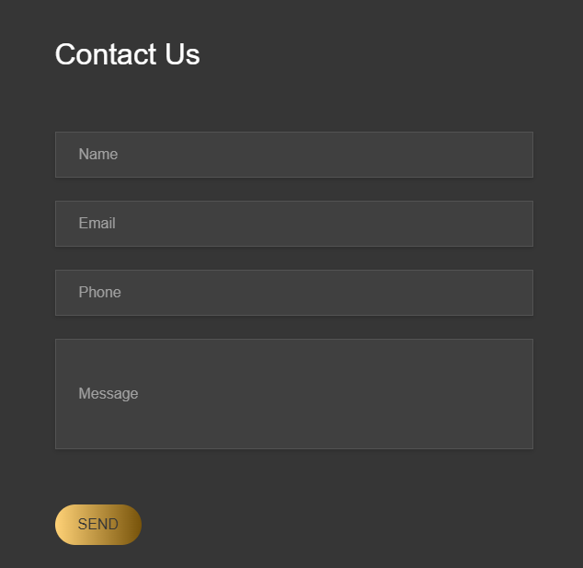WE HAVE PLACED THE CONTACT FORM IN THE HOME PAGE BECAUSE IT WILL BE EASY FOR THE WEBSITE VIEWERS BY WHICH THEY CAN PUT THEIR DATA IN THE CONTACT FORMS.

CODE

* 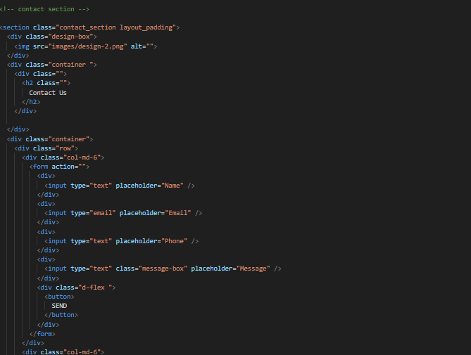THIS IS THE CODE OF THE CONTACT FORM.

GOOGLE MAP

* 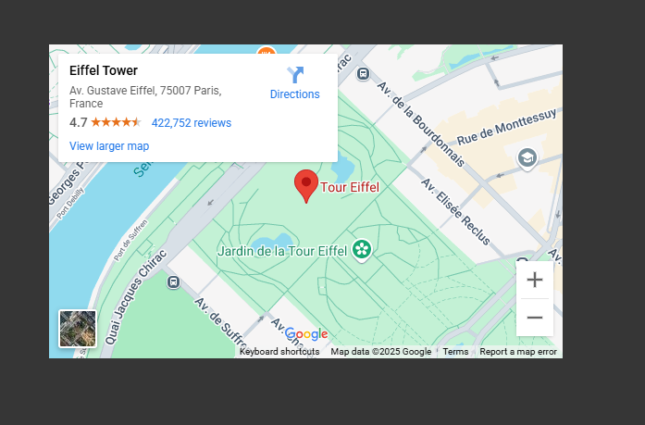WE HAVE PLACED THE GOOGLE MAP IN THE HOME PAGE OF OUR WEBSITE.
* THIS IS THE CODE OF THE GOOGLE MAP
* 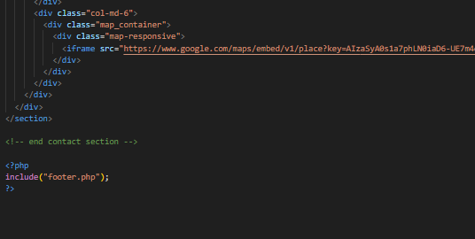IT WILL BE ESAY FOR THE CUSTOMERS TO FIND OUT OR VIEW THE MAP DIRECTIONS OF THE PLACES

FOOTER

THE FOOTER SECTION IS DISPLAYED IN THE BOTTOM OF THE HOME PAGES IN WHICH ALL THE SIDE DATA OF OUR WEBSITES WILL BE PROVIDED OUR THERE.

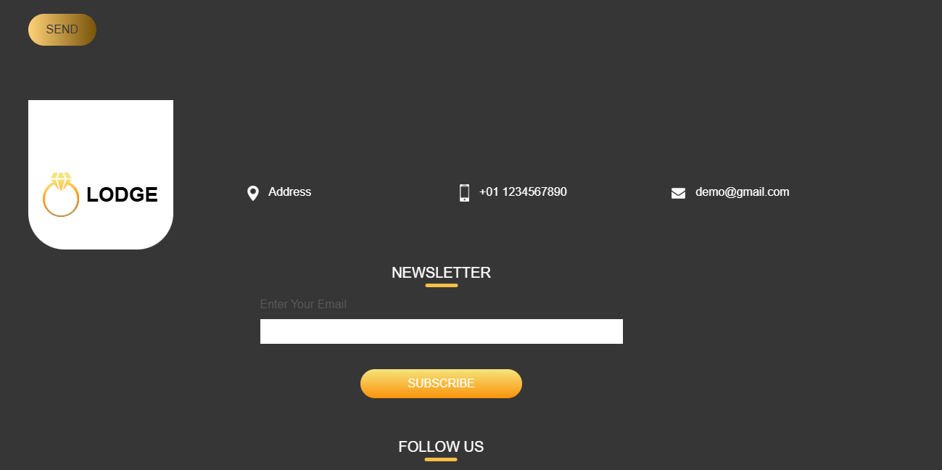

THE CODE IS GIVEN BELOW:

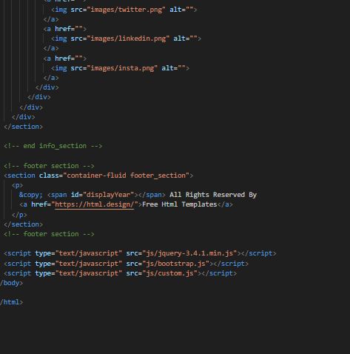

* WE HAVE PROVIDED ALL OF OUR PERSNAL AND SOCIAL DATA IN THE FOOTER WHICH WILL BE HELP FULL FOR THE CUSTOMER

CATEGORIES

* WE HAVE TWO TYPES OF THE ITEMS JEWELLERY AND THE COSMETICS

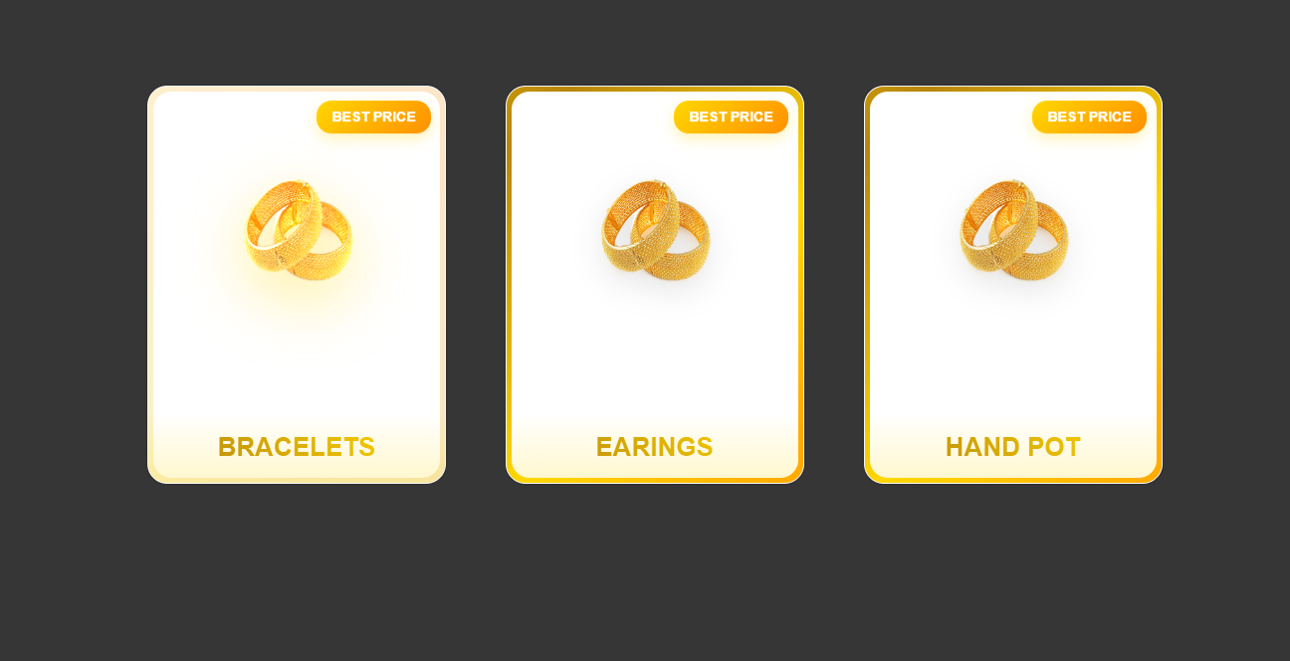

* THE MAIN THREE TYPES OF OUR ITEMS.

BRACELETS SECTION

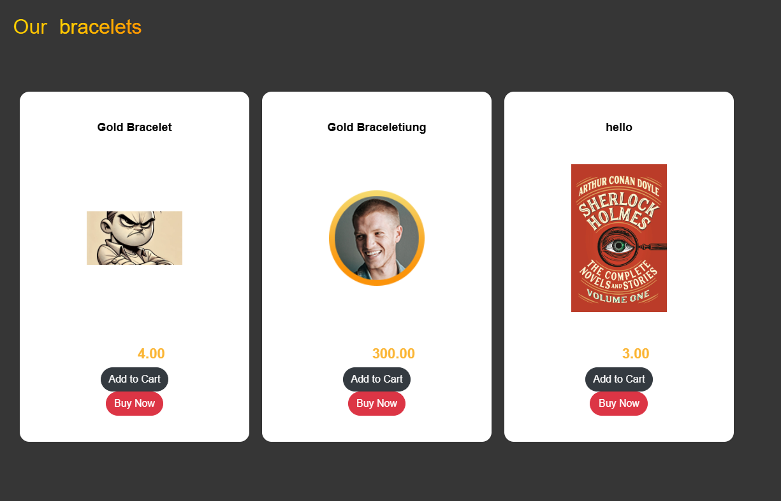

* THIS IS OUR BRACELETS SECTION IN WHICH WE HAVE DISPLAYED THE TYPES OF THE BRACELETS
* THE CODE IS GIVEN BELOW

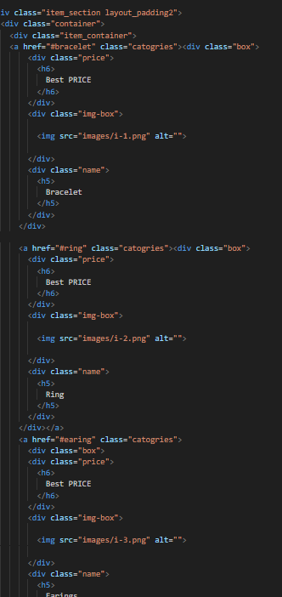

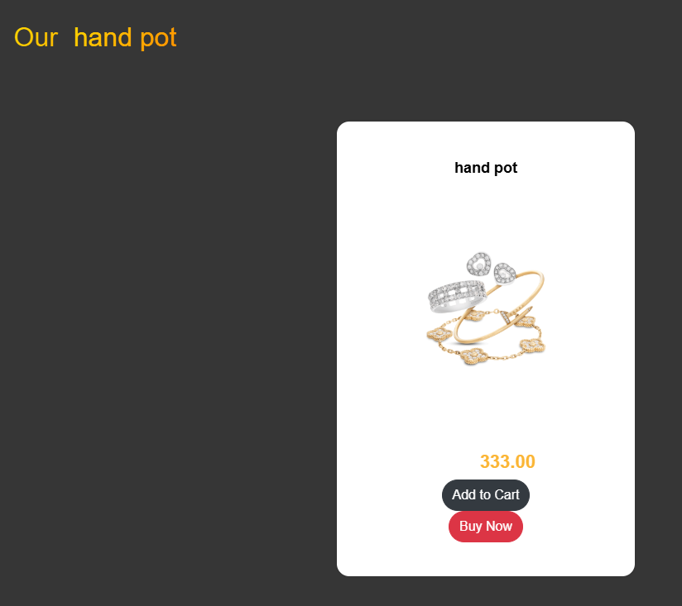HANDPOT SECTION

ABOUT US PAGE

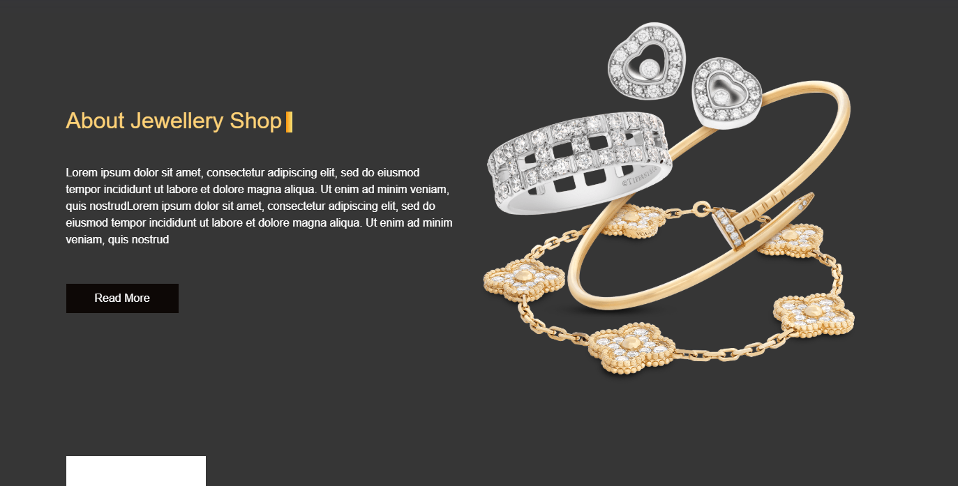

THIS PAGE SHOW ALL THE INFORMATION RELATED TO THE WEBSITE

* 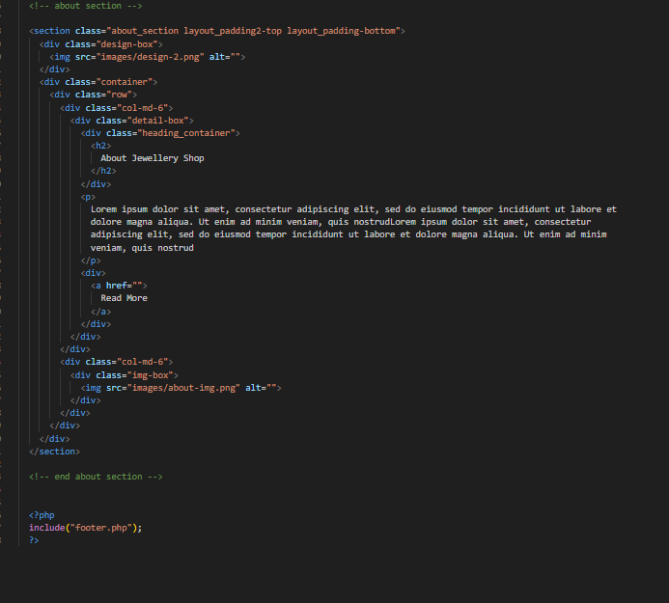THE CODE IS GIVEN BELOW

CONTACT US PAGE

* THIS PAGE IS REPRESTING HOW THE CUSTOMERS OR CLIENT WILL INTRECT WITH THE WEBSITE ADMIN AND ALSO THEY CAN CONTACT US BY INPUT THEIR INFORMATION IN THE PAGE.

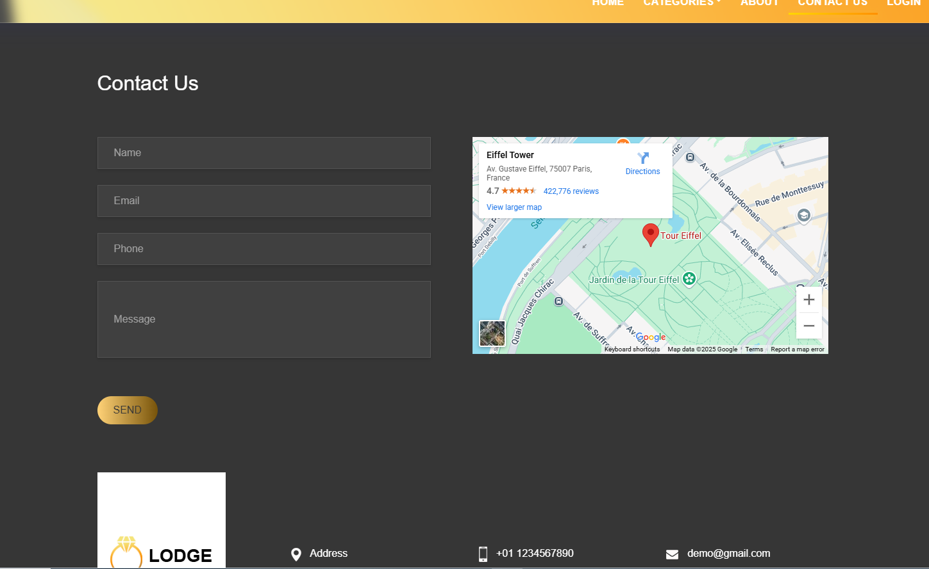

* THE CODE IS GIVE BELOW

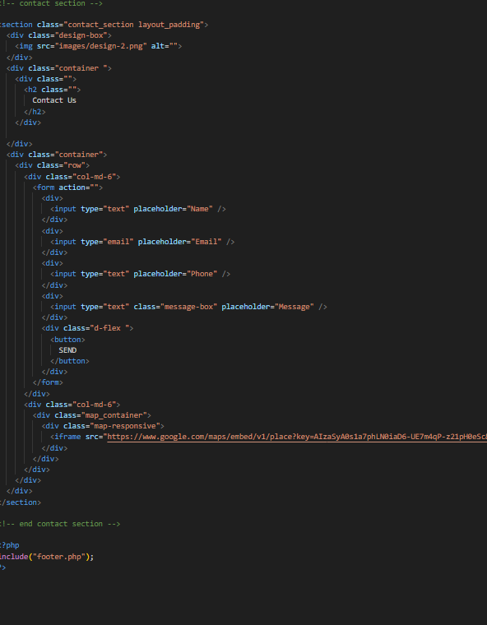

LOGIN PAGE

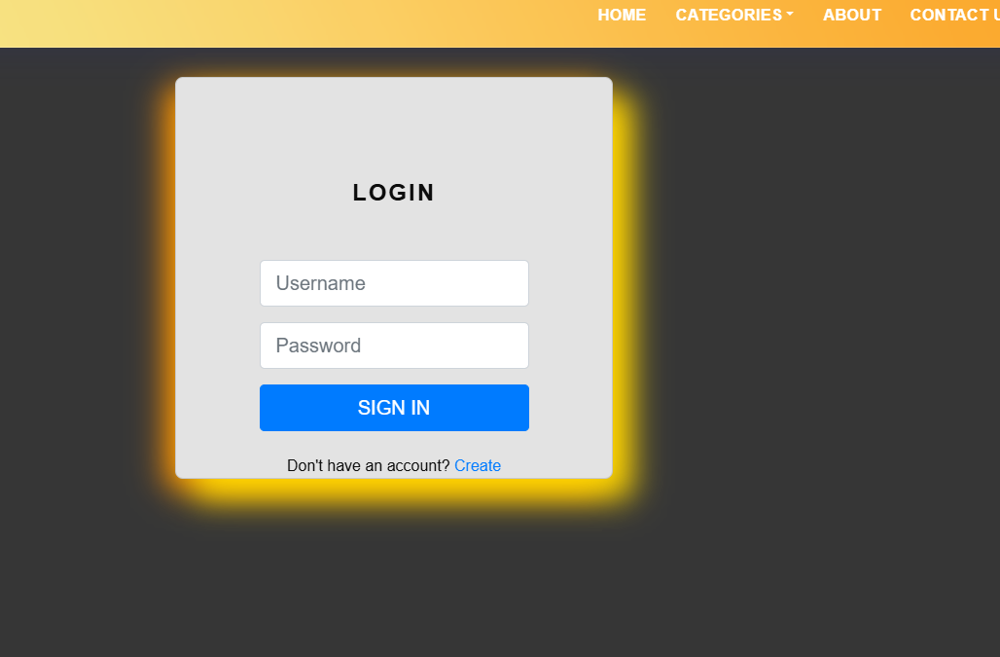IN THIS PAGE THE USER WILL LOGIN AND PUT THE PERSNAL INFORMATION BY WHICH THEY CAN ACEES MANY ITEMS

* THE CODE IS BELOW

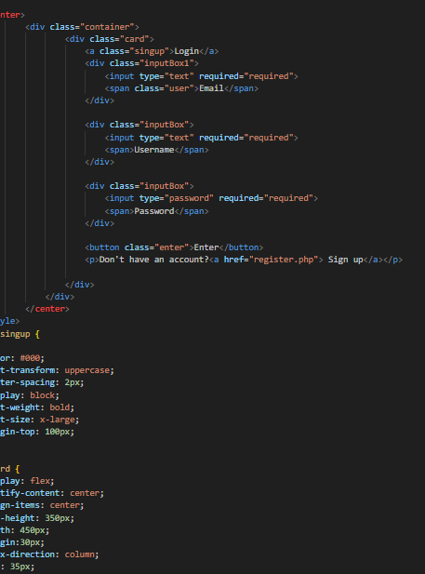

SIGN UP PAGE

* 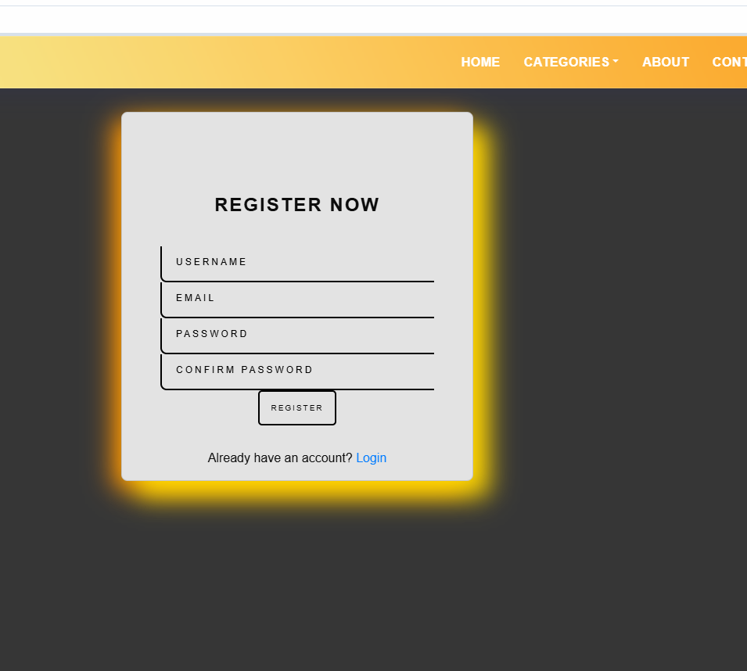IN THIS PAGE THE CUSTOMER WILL SIGNUP THEIR DETAILES
* THE CODE IS BELOW

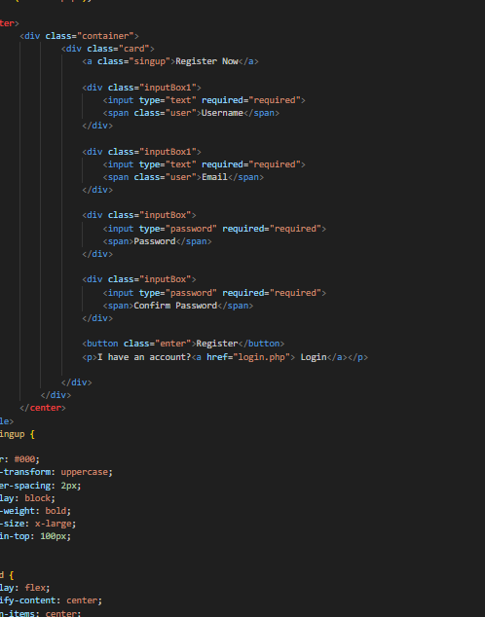

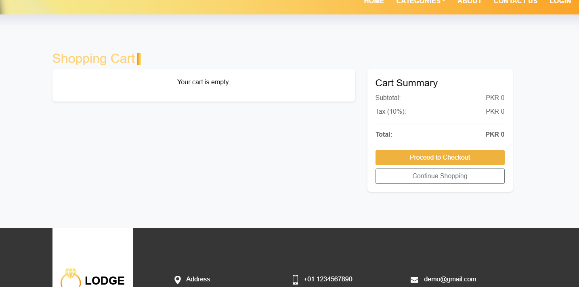ADD TO CART PAGE

IN THIS PAGE ALL THE DATA RELATED TO ADDED ITEMS WILL SHOWN CUSTOMER CAN ADD OR REMOVE THE ITEM FROM HERE

THE CODE IS GIVEN BELOW

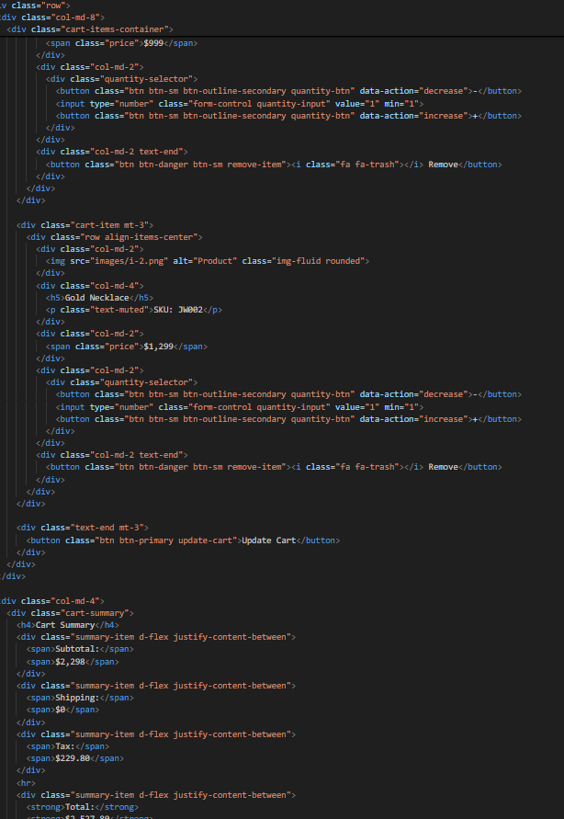

ADMIN PANEL(BACKEND)

THIS IS THE PART OF THE PROJECT CALLED THE BACKEND

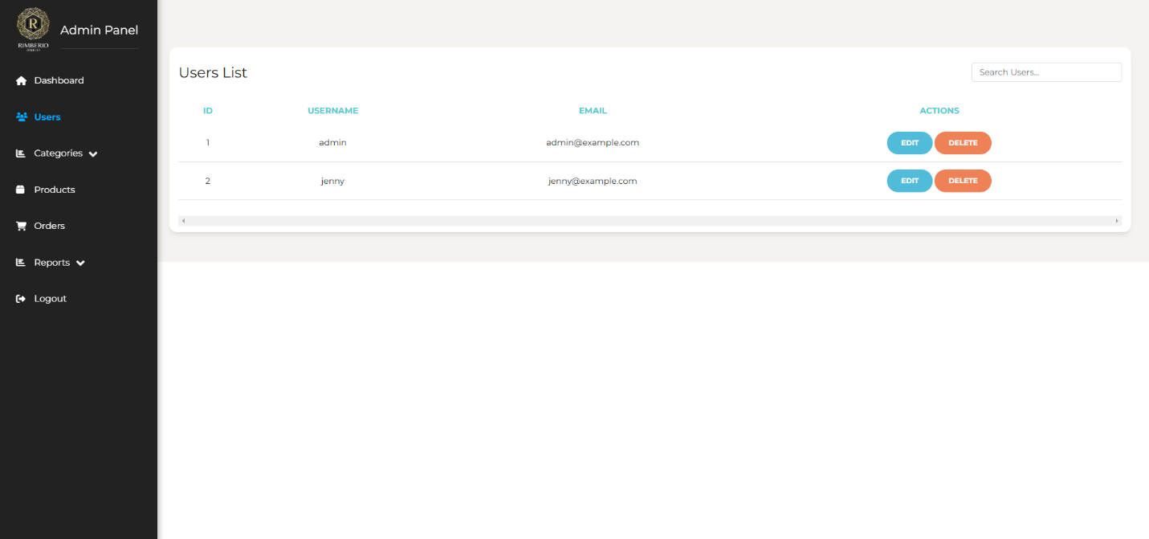

THIS IS THE MAIN INETRFACE OF THE ADMIN PANEL IN WHICH ALL THE PRODUCT ITEMS DATA WILL BE STORED HERE

* THE CODE OF INTERFACE IN BELOW

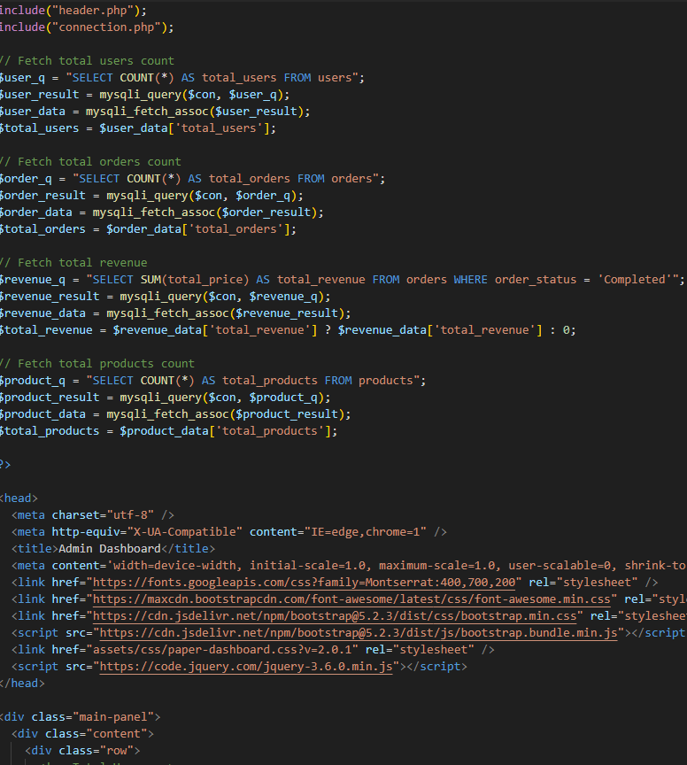

DASHBOARD SECTION

HERE ALL THE LATEST ORDER WILL DISPLAYED ALL THE DATA RELATED TO ITEM WILL BE HERE

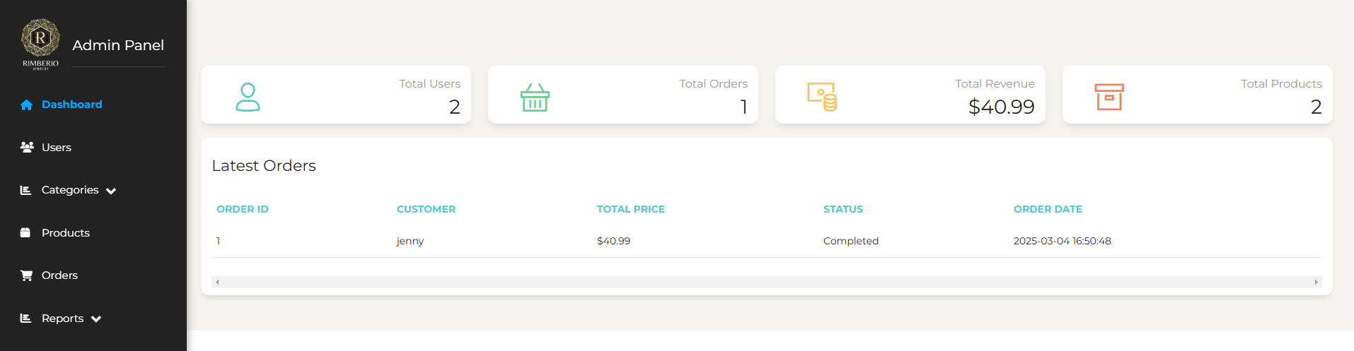

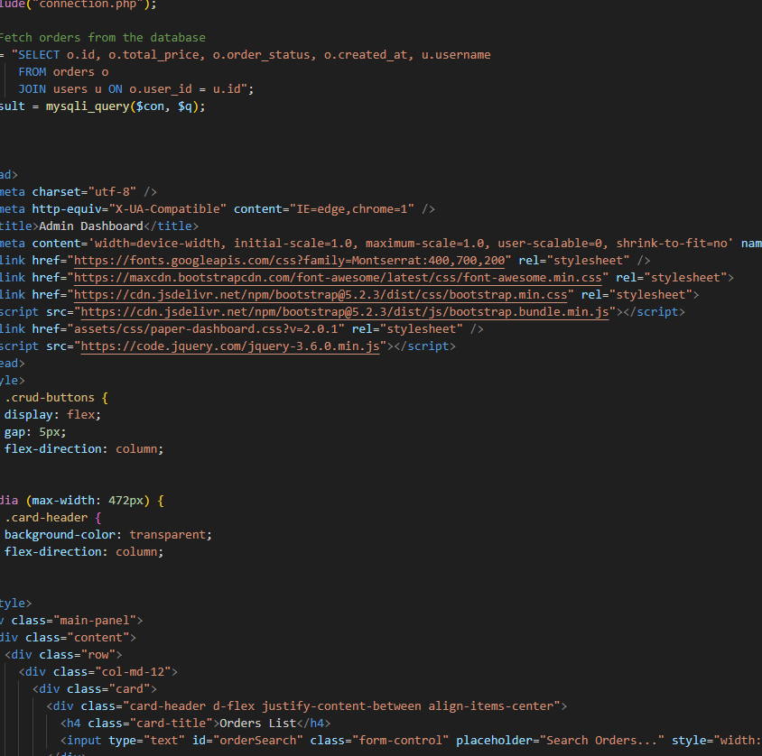

USER LIST

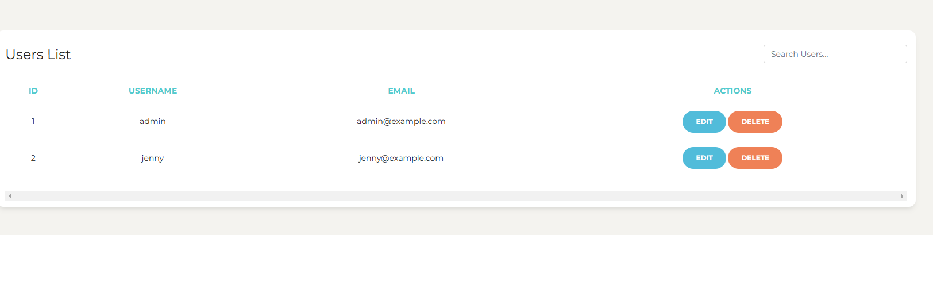

HERE ALL THE USER LIST WILL BE DISPLAYED

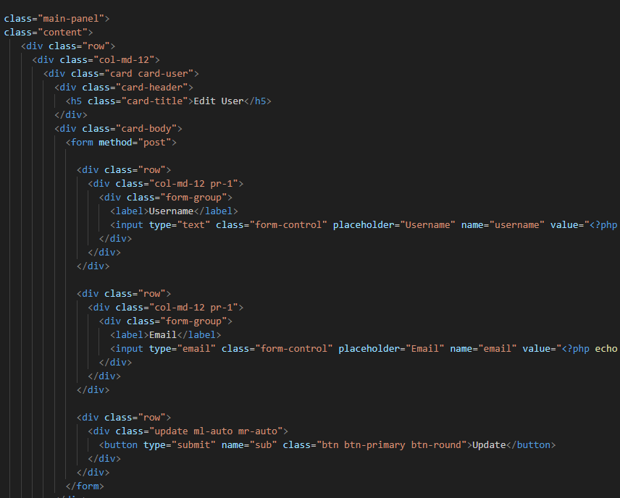

LOGOUT

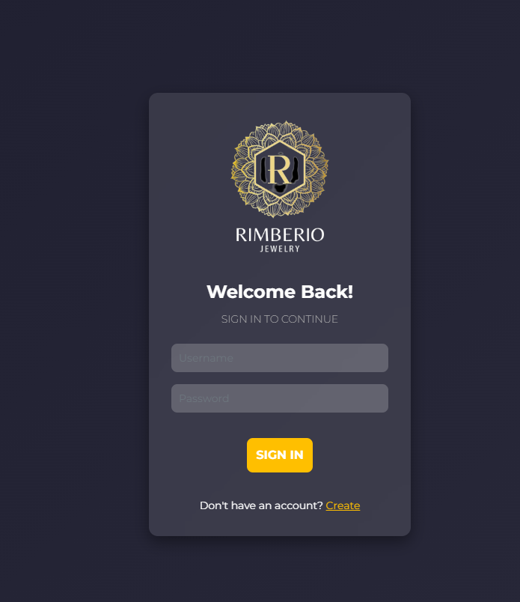

THE CODE IS BELOW

